Mikko Karkkainen 2/3/2017

11740378

Homework 1

**1.**

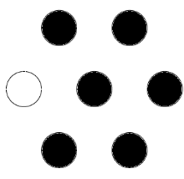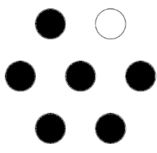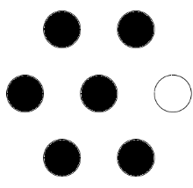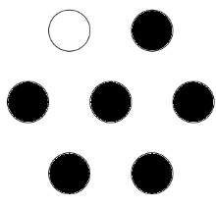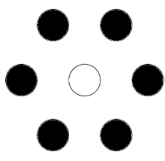

7 configurations

Configuration arrangement equation:

|  |  |
| --- | --- |
| $$Ω=\left(N_{a}+N_{b}\right)!/(N_{a}!N_{B}!)$$ | (1) |

Using no. of white spheres as $N_{a}$ and number of black spheres as $N_{b}$:

|  |  |
| --- | --- |
| $$Ω=\frac{\left(1+6\right)!}{1!6!}=\frac{7!}{6!}=\frac{7⋅6!}{6!}=7$$ | (2) |

**2.**

Chemical potential equation for a regular solution:

|  |  |
| --- | --- |
| $$μ_{i}=G_{i}+Ω{\left(1-X_{i}\right)}^{2}+RT\ln{(X_{i})}$$ | (3) |

Starting point for derivation:

|  |  |
| --- | --- |
| $$G=μ_{i}X_{i}+μ_{j}X_{j}$$ | (4) |

|  |  |
| --- | --- |
|  | (5) |

Assumption: Binary solution:

|  |  |
| --- | --- |
| $$X_{j}=1-X_{i}$$ | (6) |

Substituting eq. 6 to eq. 5:

|  |  |
| --- | --- |
| $$G=X_{i}G_{i}+(1-X_{i})G_{j}+ΩX_{i}(1-X_{i})+RT(X_{i}\ln{X_{i}+(1-X_{i})\ln{X_{i})}}$$ | (7) |

|  |  |
| --- | --- |
|  | (8) |